**Task 1: Basic User Management**

1.A front end responsive UI has been created with basic client side applications. The UI can be enhanced but due to time constraints basic UI was created.

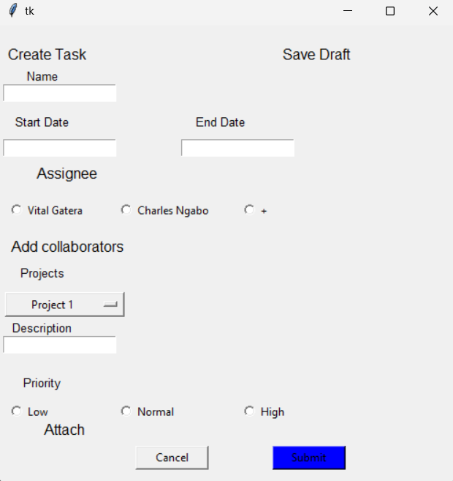

Fig 1: Overall User Interface

2. Submit and save draft functions were created and they save data or submit depending on customer decision

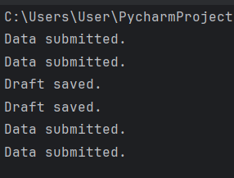

*Fig 2: Notification when submit and save draft buttons are clicked.*

🡪When data is submitted, a clear function was introduced to clear all entered data so that new data can be entered by the user.

**Task 2: Tasks Management**

1.All frontend functionalities are working fine. Including the attachment button.

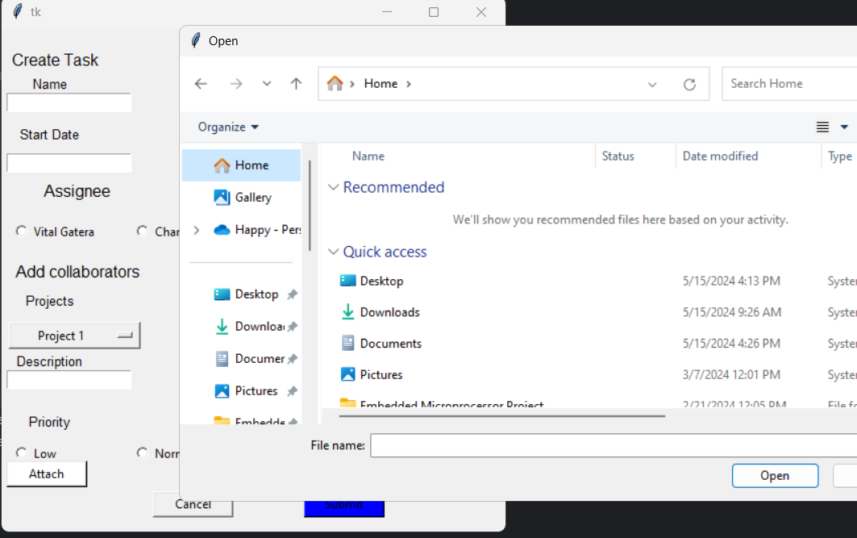

*Fig 3: Shows attach button being clicked and opens files to attach.*

2*.*Challenge encountered is that data submitted replaced already existing data. This was corrected and each time data is entered a new file is created.

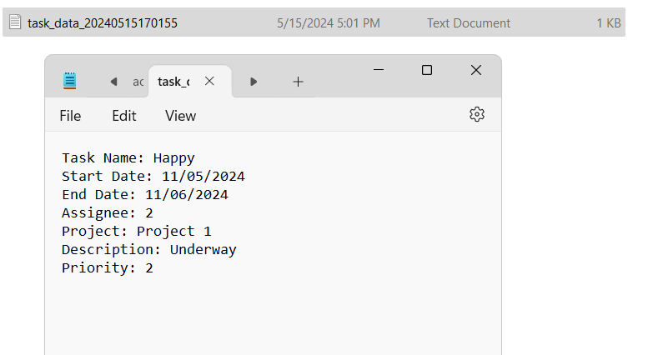

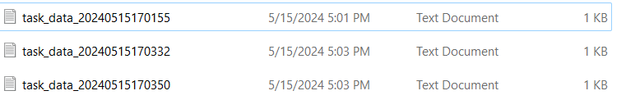

*Fig 4: Submitted files can be viewed in the folder path created.*

In conclusion, usability, application security and performance are guaranteed in this system as the user can enter data, attach files, save draft and submit it to a secure repository.